Breast Scenarios Ductal Papilloma

Description
Stem: 5 9 y postmenopausal female presenting with complaints of unilateral bloody nipple discharge from the right breast. Mammogram is unremarkable.

What is most likely diagnosis?
I ntraductal papilloma

What would you like to do now?

- Ultrasound vs MRI vs contrast ductography: US demonstrated a dilated duct in the right periareolar area

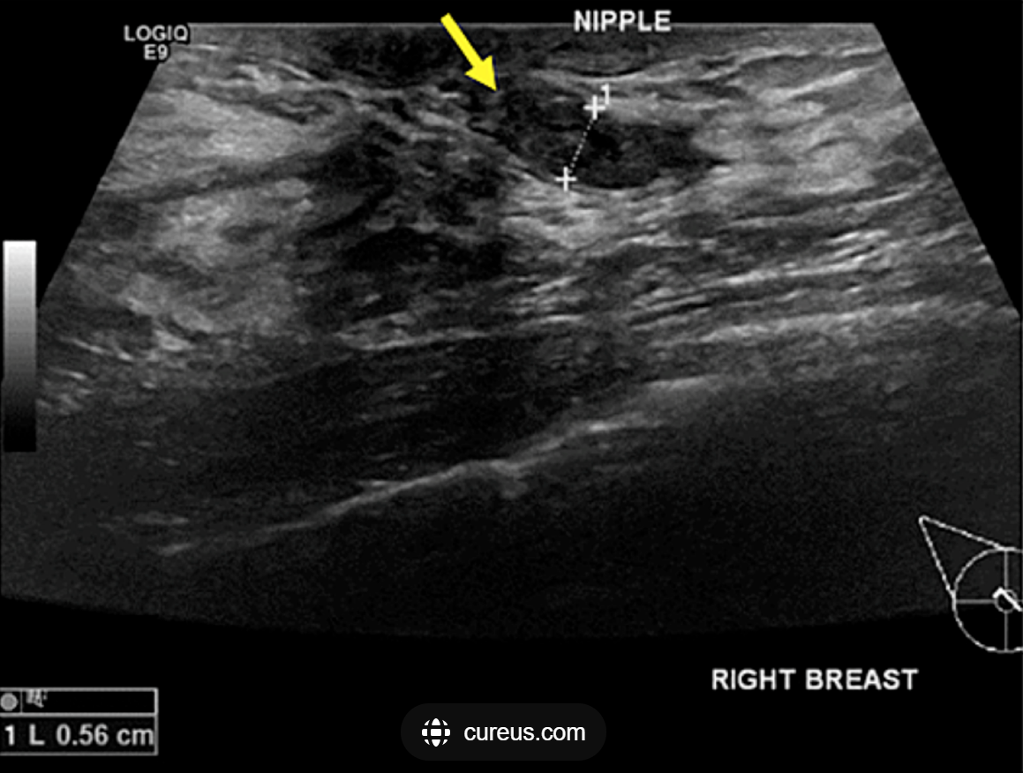

- Ultrasound guided biopsy: indeterminate

- OR:

Describe:

- Terminal duct excision/excisional biopsy
- I nsert a fine lacrimal duct probe into the dilated duct.
- M ake a periareolar incision (no more than 30% circumference
- I solate the affected duct
- R esect the subareolar region with the abnormal duct attempting to preserve unaffected duct(s) if possible.

- Pathology : Confirming.

